This assignment expects the participant to identify specific command(s) OR perform the given action using one or commands as per the given question. You are requested to maintain the answers (i.e command(s) as per given question) for all questions below.

Mandatory Questions

1. Which command is used to know the current working directory?

=> pwd

2. How would you find out its contents?

=>ls

3. Identify the commands with inputs to do the following

a. create a directory d1

=>Mkdir d1

b. create a subdirectory d2 in d1

=>mkdir -p d1/d2

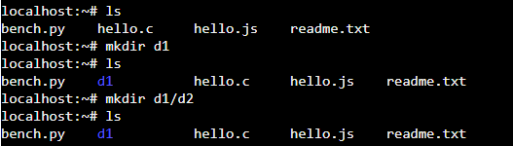

c. change to directory d2

=>cd d2

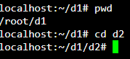

d. create an empty file “f1.txt”

=>touch f1.txt /cat > f1.txt

e. display the contents of “f1.txt”

=>cat f1.txt

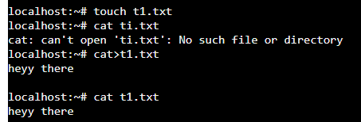

f. view the contents of d1 from current directory d2

=> ls -p

4. Use the ls command with its options. How will you identify directories from the listing?

=>ls -1

5. Use ls to do the following

a. List files with single character names.

=>ls -d f\*

b. List hidden files also. [ Note : Hidden files are files having name started with a “.” ]

=>-ls -a a\*

c. Suppose there are files tb1.1, tb2.1, tb3.1, ….tb10.1. Write command to list all the files [Hint: use wild card characters]

=>ls t\*

6. Write the command to list all files in descending order of their size.

=> ls -lS

7. Suppose there are files temp1, temp2, temp3. Write command to remove the files without listing them explicitly

=>rmdir filename / rm -v !("filename")/rm -r filename

8. Which command is used to list top few lines in the file?

Head filename

9. Create a directory “testdir”

Mkdir testdir

10. Use cp command to do the following

a. Copy the file tb1.1 (created above) in the same directory.

Cp tb1.1 / cp /home/home/f1.txt /home/abc/testdir

b. Write a command to copy all the files i.e tb1.1,tb2.1,tb3.1,…..tb10.1 in a new directory –“new”

c. Create a subdirectory in new in named“new1”.

Ans- mkdir -p new/new1

d. Write a command to copy selectively only tb2.1, tb6.1, tb7.1 and tb10.1 in the directory new1.

e. Write a command to copy the entire directory “new” to a directory “newprogs”. [Note : use the –R option of “cp” command ]

Ans- cp –R /home/abc/new /home/abc/newprogs

11. Find out the difference between

a. “mv” & “cp”

ans-The cp command will copy your file(s) while the mv one will move them.

b. “rm”, “rmdir”

use to remove file

eg:- Dimanshu.txt

rm Dimanshu.txt

use to remove directory

eg:-mkdir Dimanshu

its will remove this folder

c. “mkdir” and “mkdir -p”

Ans-Mkdir will create the directory in default directory path or current working directory path in which powershell window is open. mkdir - p creates the directory in the path mentioned by you

12. Use a single command rmdir once to remove “testdir” and all its sub directories and files created above.

13. Which command is used to get the manual information of a command?

Ans-man

14. If you are not able to change to a directory what could be the likely cause?

Ans-permission denied

15. Explain the differences among the following commands:

Cd/ means it will take in the root dir

Cd .. change dir as you are in home/abc/d2 path then after the using this command its path will be home/abc

Cd change dir

Cd ../..

Advance

1-An inode is a file data structure that store information about any Linux file except its name and data

ls -i

2- | symbol

Eg- ls -l |more

the pipe command lets you sends the output of one command to another

3- he ps command is used to view currently running processes on the system. It helps us to determine which process is doing what in our system, how much memory it is using, how much CPU space it occupies, user ID, command name, etc